Date | Lesson | Title | Reading
Sep 13 | 1 | Why Bother With the Bible? | Nehemiah 8:1-18;  Luke 24:13-35
Sep 20 | 2 | Creation as Kingdom Making | Genesis 1:1-2:3
Sep 27 | 3 | The Installation of Kings | Genesis 2
Oct 4 | 4 | Abdication | Genesis 3 and 4
Oct 11 | 5 | Destruction of the Kingdom | Genesis 6:1-9:17
Oct 18 | No Class – Reformation at 500 Lecture Series at College
Oct 25 | 6 | Planting Seeds | Genesis 12:1-9; 15:1-21; 26:1-5, 28:10-17
Nov 1 | 7 | Creation of a New Kingdom | Exodus 11-14
Nov 8 | 8 | Abdication, Redux | Exodus 32-34
Nov 15 | 9 | Dwelling Place of God is with Men | Exodus 35:30-38:20; and Exodus 40
Nov 22 | No Class – Thanksgiving Holiday
Nov 29 | 10 | Dealing with Sin | Leviticus 16
Dec 6 | No Class – Lessons and Carols at Holy Trinity
Dec 13 | 11 | The Law a Blessing and a Curse | Deuteronomy 4:1-9:12;  and chapters 28 and 30
Dec 20 | 12 | God’s Holy D-Day | Deuteronomy 20  and Joshua 6
Dec 27 | No Class – Christmastide
Jan 3 | No Class – Christmastide
Jan 10 | 13 | Reclaiming the Throne | 1 Samuel 8-10; 15-17
Jan 17 | 14 | God’s Anointed Man | 2 Samuel 7
Date | Lesson | Title | Reading
Jan 24 | 15 | Bad Kings and Good Prophets | 2 Kings 17:1-23; and  2 Chronicles 36
Jan 31 | 16 | Prophets and Promises | Jeremiah 31:31-40; Ezekiel 36:16-37:28
Feb 7 | 17 | God’s Anointed Man, Redux | Isaiah chapters 42; 49; 50:4-9; and 52-53
Feb 14 | No Class – Ash Wednesday
Feb 21 | 18 | Advent of the Kingdom | Nehemiah 9
Feb 28 | 19 | The Second Adam | Luke 3:1-4:30
Mar 7 | 20 | The Second Exodus | Mark 6:30-52; and John 6:22-71
Mar 14 | 21 | The Second Moses | Matthew 5-7
Mar 21 | 22 | The Second Temple | John 2:13-22; and John 14-17
Mar 28 | No Class – Holy Week
Apr 4 | 23 | The Second David | Matthew 21-23;  and chapter 26:1-5
Apr 11 | 24 | Full, Perfect, and Sufficient | Hebrews 7-10
Apr 18 | 25 | The Firstborn of All Creation | John 20; and Pascha Nostrum (BCP p. 162-3)
Apr 25 | 26 | Re-Reading the Story | Galatians 3-5; and Romans 6-8
May 2 | No Class – CANA East Synod
May 9 | 27 | * Becoming Nothing | Philippians 2:1-18
May 16 | 28 | That We Might Have Everything | John 1:1-14 and  Colossians 1:15-3:17
May 23 | 29 | In Him * | Ephesians 2-4 and  5:22-33
May 30 | 30 | Dwelling Place of God, Redux | Revelation 4-5; and 20:11-22-end

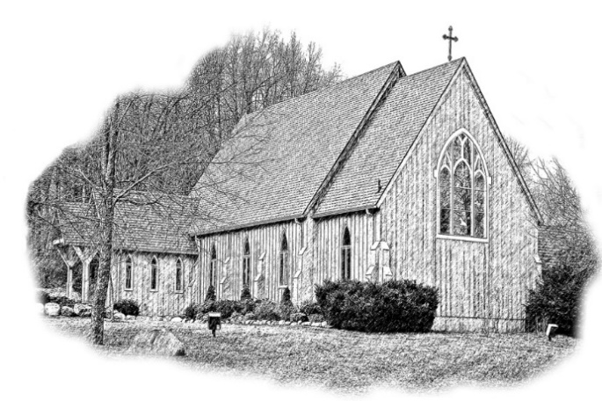

Holy Trinity Parish
Hillsdale, Michigan

We are a traditional Anglican parish ministering to the servants of God in south central Michigan, the tristate area, and on the campus of Hillsdale College since 1990.

Sunday service time: 10:30 am, Holy Communion
263 Spring Street, Hillsdale, Michigan 49242

Contact us:
(517) 437-3300 | www.trinityhillsdale.org
Contact Fr. Adam
(517) 392-7994 | adam@trinityhillsdale.org

Holy Trinity Parish is a congregation of the Missionary Diocese of CANA East
and is part of the Anglican Church in North America.

God Becomes Man
Reading the Bible as a Story

Christian Education Series 2017-18
Wednesdays at 6:30 pm (Evening Prayer at 6:00 pm)

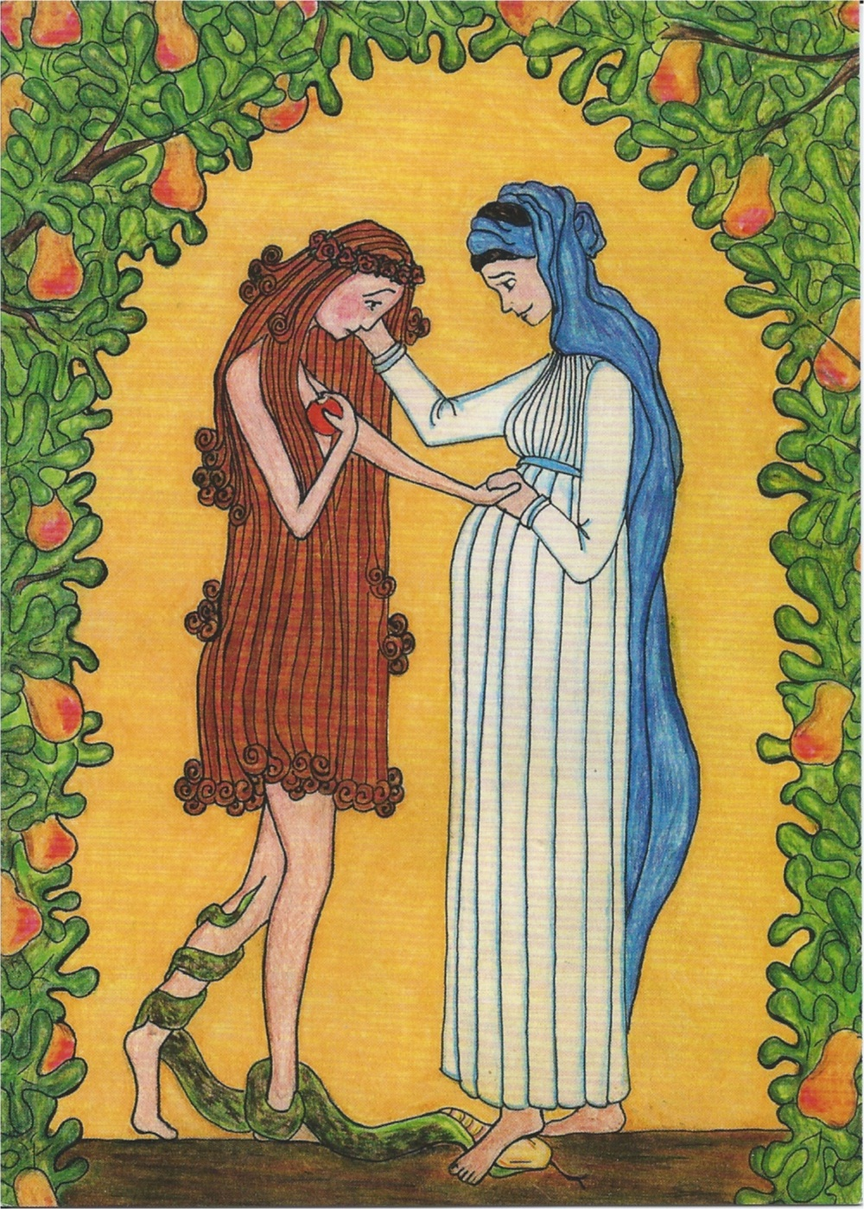
“Virgin Mary Consoles Eve”
by Sister Grace Remington OCSO, 2005, Dubuque, Iowa

Schedule of Subjects and Readings

Follow the Series Online:
LIVE: www.facebook.com/hillsdaleanglican/
AFTER: www.trinityhillsdale.org/blog/category/god-becomes-man

